Instructions for Renewing Membership:
1) Go to the ASA website and click the “My ASA Portal Login” in the top right corner, then create an ASA account or log in to your existing ASA Membership portal.

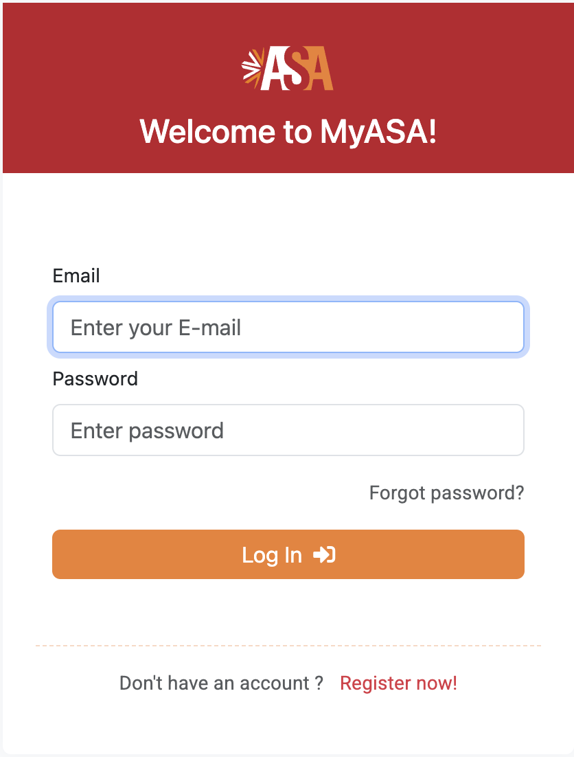

2) After you log in, you will be brought to your dashboard. In the column/menu on the left, you want to select “Coordinate Organizations.”
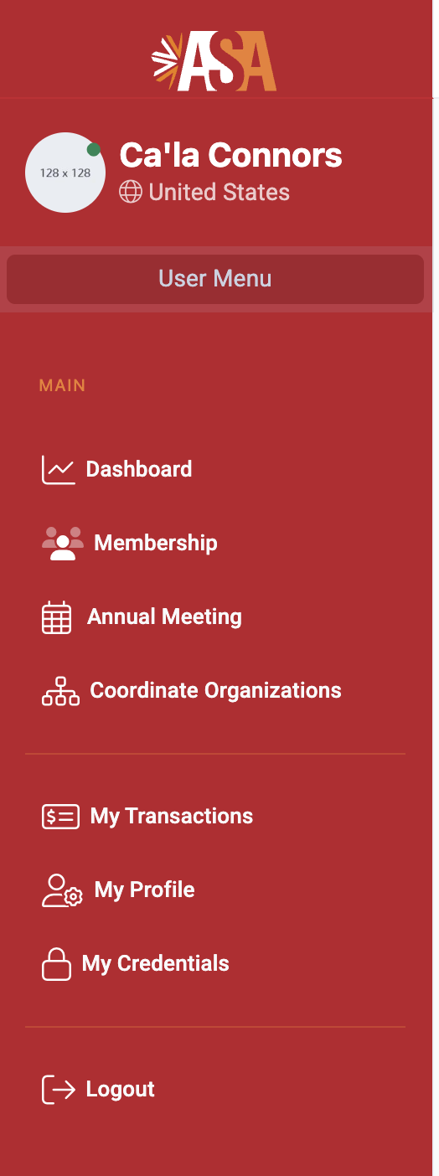

3) This will bring you to a page that lists all the coordinate organizations of the ASA. To add your NAASC membership to your cart, select one of the membership level options under the heading "North American Association of Scholars on Cameroon (NAASC) Membership.” This should be the second option on the page, so you shouldn't have to scroll far to find it. After you select your membership tier, scroll all the way down to the bottom of the page and select the yellow “Add to Cart” button. NOTE: Feel free to add any other coordinate organizations of interest to the cart here as well, if you’d like.

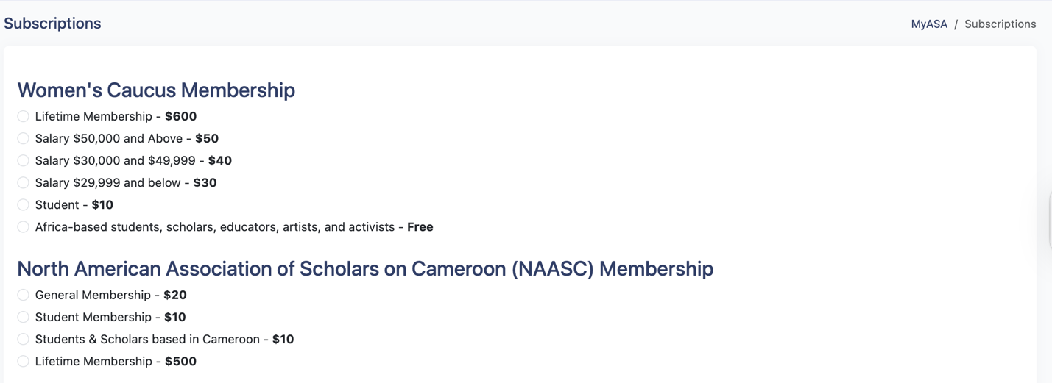

4) After you select “Add to Cart,” you’ll be taken to view your cart. From there, verify that you have selected the correct coordinate organization and membership tier. Then select “Checkout" and follow the payment instructions until complete.

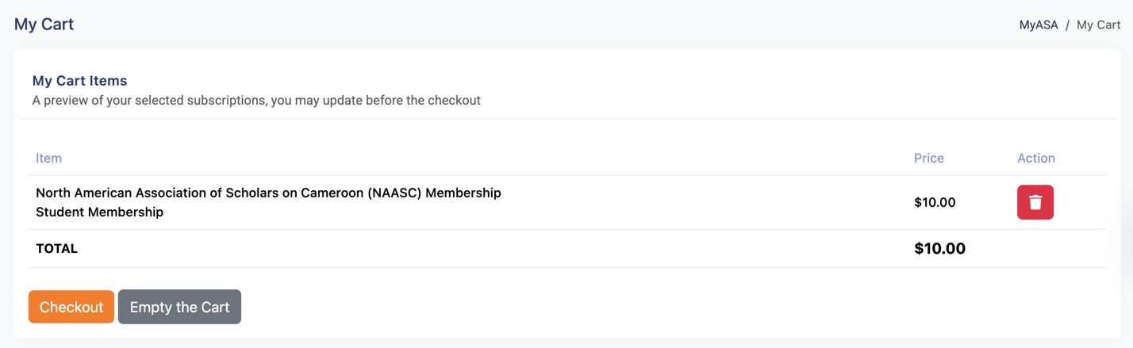

5) CONGRATULATIONS! You will have successfully joined NAASC for the 2026 calendar year!

